**Practice Assignment 6**

**Link Github:** [**https://github.com/VyHoang245/HoangThiThuyVy_Lab6**](https://github.com/VyHoang245/HoangThiThuyVy_Lab6)

Exercise 1:

1. What are Reflection and Expression Trees?

* Reflection is the process of describing the metadata of types, methods and fields in a code. The namespace **System.Reflection** enables you to obtain data about the loaded assemblies, the elements within them like classes, methods and value types.
* Expression tree

1. Analyze the redundancy in the above code.

* The provided code has redundant logging methods (LogUserAction, LogTransaction, and LogError). Each method logs a different type of message, but they all follow a similar pattern, which leads to code duplication.

1. Rewrite the code using Reflection or Expression Trees to eliminate redundancy in logging.

Exercise 2:

1. Identify DRY violations in the above code.

* **Duplicate Code Structure**:
* Both StudentRepository and TeacherRepository have nearly identical logic for database connection and retrieval.
* The GetAllStudents() and GetAllTeachers() methods follow the same pattern, differing only in table names and entity types.
* **Redundant Database Handling**: Both repositories directly create SqlCommand objects and execute ExecuteReader(), which can be abstracted.
* **Lack of Reusability**: If a new entity (e.g., Course) is introduced, similar repository code would need to be written again.

1. Rewrite the code using Generic Repository Pattern combined with Dependency Injection to reduce redundancy.

Exercise 3:

1. Identify redundancy in the above code.

* **Duplicate Code Structure**: Each controllers manage a different type of object, but they all follow a similar pattern, which leads to code duplication.

1. Rewrite the code using a Generic Base Controller and Generic Constraints to reduce duplication in API request handling.

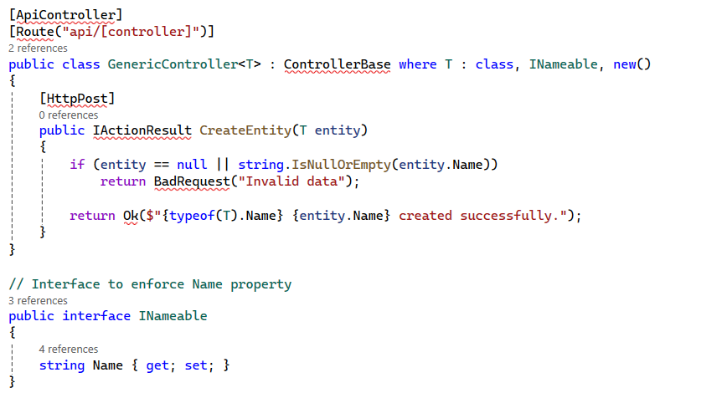

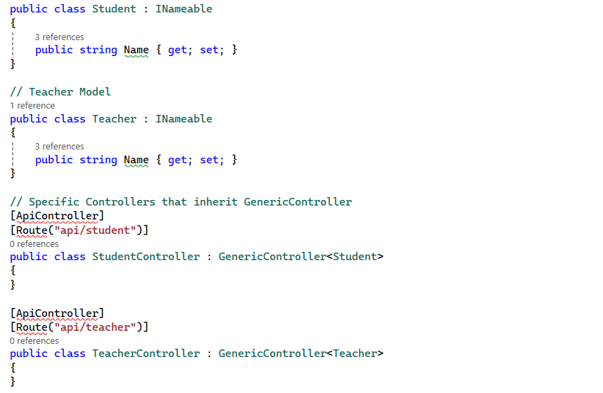

Exercise 4:

**1. What are Strategy Pattern and Factory Pattern?**

* **Strategy Pattern**: It defines a family of algorithms (strategies), encapsulates each one, and makes them interchangeable at runtime. It allows selecting a payment method dynamically without modifying the existing code.
* **Factory Pattern**: It provides an interface for creating objects in a superclass but allows subclasses to alter the type of objects created. It helps centralize object creation logic.

**2. Identifying DRY Violations in the Given Code**

* The code **violates the DRY (Don't Repeat Yourself) principle** because:
  1. **Duplicate Method Logic**: Each method does the same thing—logs a message—with only minor differences in text.
  2. **Tightly Coupled Code**: The PaymentService class is tightly coupled with specific payment types. Adding a new payment method requires modifying the class, which breaks the **Open/Closed Principle**.
  3. **Refactored Code Using Strategy Pattern + Factory Pattern**

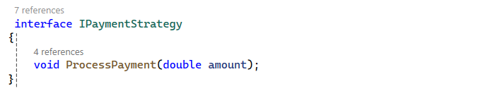

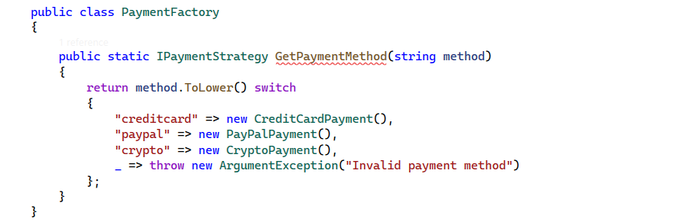

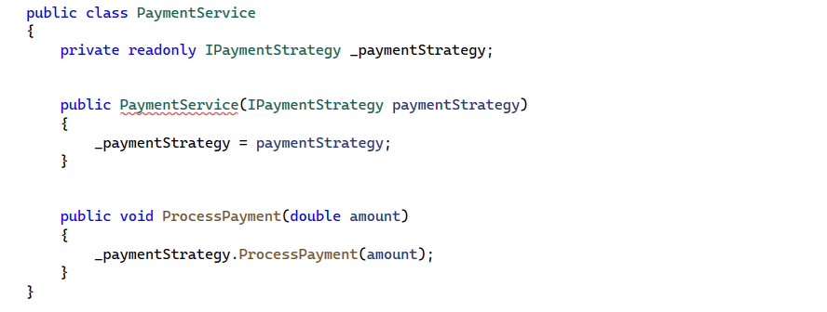

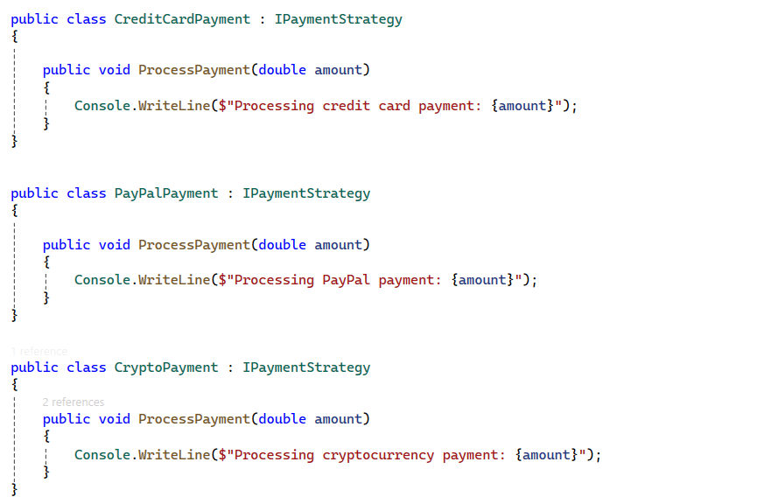

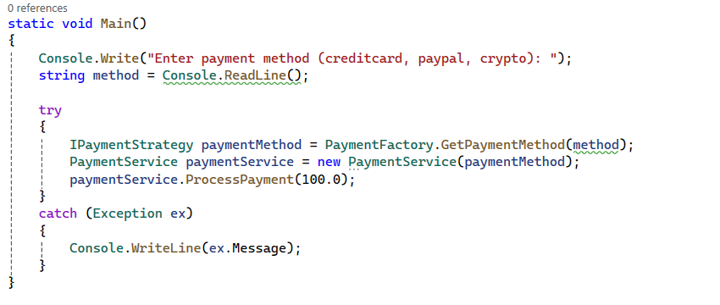

Exercise 5:

**1. Identified Redundancy in Cache Handling**

* **Both UserService and ProductService contain identical caching logic.**
* **The _cache dictionary and its lookup logic (checking if a key exists, fetching from the cache or database) are duplicated.**
* **Code Duplication: If another service needs caching, we must rewrite the same logic again.**
* **Violates Single Responsibility Principle (SRP): Services should focus on fetching users/products, not handling caching.**

### 2. **Refactored Code Using the Decorator Pattern**

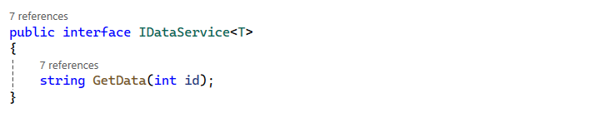

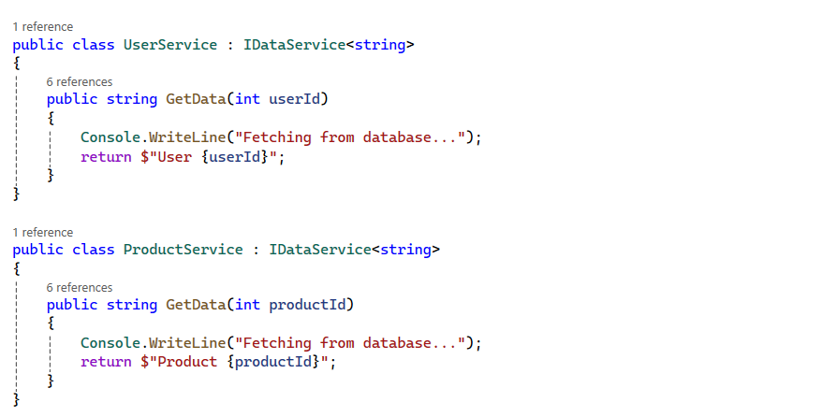

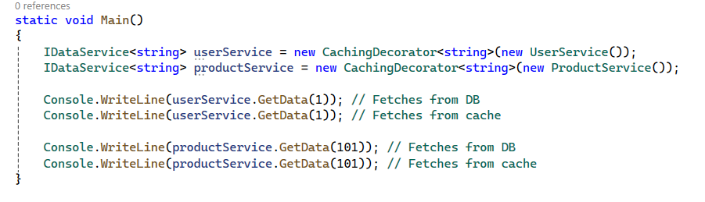

Exercise 6: Based on the principles of Packages in Architecture, design a solution in .NET consisting of multiple projects, where each project serves as a package responsible for a specific functionality. Determine the minimum number of projects required to build a complete library management system, and explain the role of each project within the overall architecture. Ensure that the system is scalable, maintainable, and can be easily upgraded in the future.

**Minimum Number of Projects Required**

A clean and layered architecture requires at least six core projects:

1. LibraryManagement.Core (Domain Layer)
2. LibraryManagement.Application (Application Layer)
3. LibraryManagement.Infrastructure (Infrastructure Layer)
4. LibraryManagement.Persistence (Data Layer)
5. LibraryManagement.API (Presentation Layer)
6. LibraryManagement.Tests (Testing Layer)

**Project Breakdown & Responsibilities**

**1. LibraryManagement.Core (Domain Layer)**

* Contains **business entities, domain models, and interfaces**.
* Defines core entities like Book, Member, Loan, and Librarian.
* Contains **domain-driven business logic** and **rules**.

**2. LibraryManagement.Application (Application Layer)**

* Contains **use cases, business logic, and service interfaces**.
* Implements **CQRS (Command-Query Responsibility Segregation)**.
* Uses **DTOs (Data Transfer Objects)** for communication.

**3. LibraryManagement.Infrastructure (Infrastructure Layer)**

* Implements **third-party services, logging, authentication, and caching**.
* Provides services like **email notifications, cloud storage, or external APIs**.

**4. LibraryManagement.Persistence (Data Layer)**

* Handles **database interactions** using **Entity Framework Core**.
* Manages **Repositories & Unit of Work Pattern**.
* Stores **Books, Members, Loans, and Librarians**.

**5. LibraryManagement.API (Presentation Layer)**

* Exposes the system as **RESTful APIs**.
* Uses **ASP.NET Core MVC/Web API**.
* Implements **Controllers for Book, Member, and Loan Management**.

**6. LibraryManagement.Tests (Testing Layer)**

* Contains **unit tests and integration tests**.
* Uses **Moq, xUnit/NUnit** to test business logic.